VIRAL FUSION
Presentation Update — 10.23.26
Slides 1–33 | The Blueprint
Single editor master: Slides 1–10 + unchanged bridge slides from 10.4.26; revised 10.9.26 copy where updated.

SLIDE 1

Start: Let’s open with Tulsi: https://www.youtube.com/watch?v=EMxgI9kdTyY
0:36
I will start with one of my favorites, Abraham Lincoln. when he was 28 years old, he gave an iconic speech that
0:44
people don't really talk about enough because he wasn't president at the time, but it's it's has been one of the most impactful speeches for me. It was in
0:53
53 seconds
Springfield, Illinois, and it was at the lysum, and I'll give you one line from it, but encourage you to go and look it up. He said, "If
1:01
1 minute, 1 second
destruction be our lot, we must ourselves be its author and finisher.
1:09
1 minute, 9 seconds
As a nation of free men, we must live through all time or die by suicide.”
1:18
1 minute, 18 seconds
As a nation of free men, we must live through all time or die by suicide.
1:26
1 minute, 26 seconds
It doesn't get much more direct than that. As we think about every one of us and our own individual and collective responsibility
1:34
1 minute, 34 seconds
to carry on the legacy of freedom that our founders envisioned for this great country. And what better time to do that
1:43
1 minute, 43 seconds
than now as we head into this election and now as we observe and celebrate 250 years since our country declared its independence.
3:12
3 minutes, 12 seconds
So if we want to keep living free in this amazing country that we love, every one of us has to heed Abraham Lincoln's
3:20
3 minutes, 20 seconds
warning and take that responsibility upon ourselves. When we look at our constitution and we look at those who

Chapter 2: Government overreach
3:28
3 minutes, 28 seconds
who drafted the constitution, they were very intentional in the first three words that they chose in writing the preamble. What is it?
3:37
3 minutes, 37 seconds
We the people.
3:39
3 minutes, 39 seconds
We the people. You got it. [laughter] But what does we the people mean? It's
3:46
3 minutes, 46 seconds
more than just three words. It is a reminder and a call to action to every single one of us.
3:52
3 minutes, 52 seconds
To every single one of us, reminding us that the power that this government has comes from us. It's not the other way around.
4:02

SLIDE 2
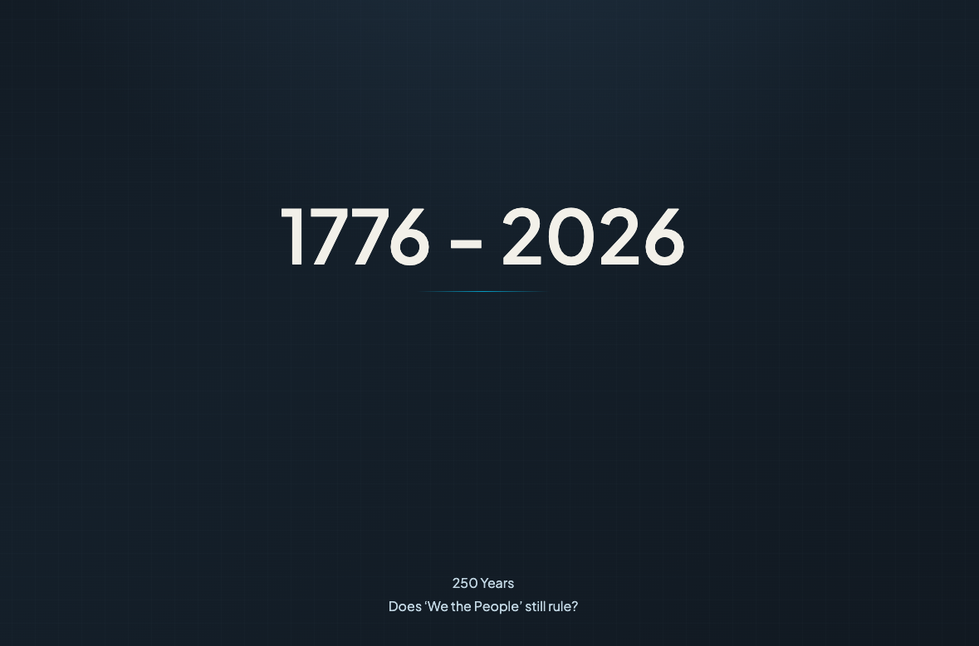

On screen

SLIDE — 1776–2026
250 YEARS — DOES “WE THE PEOPLE” STILL RULE?

[GEORGE]
Direct, unapologetic. Building conviction.
250 Years.
Let's be completely honest with ourselves.
The Founding Fathers are rolling in their graves.
But the timing is aligned for change—if we're willing to seize the opportunity.
A movement can start with one man—
someone who executes a strong vision with absolute conviction and puts in the time.
His vision wasn't absolute.
But look at what it turned into.
EDITOR CUE — JEETU: CHARLIE KIRK / TPUSA ARCHIVAL FOOTAGE] https://www.youtube.com/shorts/XnKxnoZMCjM
Transition from the 1776–2026 graphic to authentic archival footage of Charlie Kirk throwing hats into the crowd at a Turning Point USA event.
Begin the footage as George introduces the idea that a movement can start with one man.
On:
“But look at what it turned into.”
Transition to a wider shot of the TPUSA audience.
Use approximately 5–8 seconds, adjusted to the voiceover timing.
Use authentic, appropriately licensed footage.

[GEORGE]
Measured, strategic.
But the people are ready for more than talk and debate.
We've had plenty of that over the decades.
And simply showing up to vote hasn't always delivered the results people were promised.
Yet election after election, we continue hearing our political leaders make the same appeals.

[EDITOR CUE — JEETU: TULSI GABBARD VIDEO]
SOURCE: Tulsi Gabbard interview
TIMESTAMP: 4:02–4:18
VIDEO EXCERPT (verify against source): https://www.youtube.com/watch?v=EMxgI9kdTyY
“And that is where our responsibility comes into play... not only to choose who we want to vote for in an election, but once the election passes to ensure that those leaders are carrying out the promises and their responsibility to that oath that they take to the Constitution.”
Play the original audio without overlapping narration.
Allow her final reference to the Constitution to land before resuming George's voiceover.

[GEORGE]
Measured, strategic. Questioning public trust and accountability.
So I have to ask you:
Do our votes count? With absolute certainty?
And how do we actually hold our leaders accountable—
to the promises they've made to the people,
and the oath they've sworn to the Constitution?
What do we do when our constitutional republic is no longer working for “We the People”?
When our elected representatives serve interests other than those of the citizens they're supposed to represent?
When political leaders speak of protecting our democracy—
yet the system doesn't provide a meaningful way to create change?

[EDITOR CUE — JEETU: CONSTITUTIONAL ACCOUNTABILITY]
As George says: What do we do when our constitutional republic is no longer working for “We the People”? Should we bring in the creative from slide?
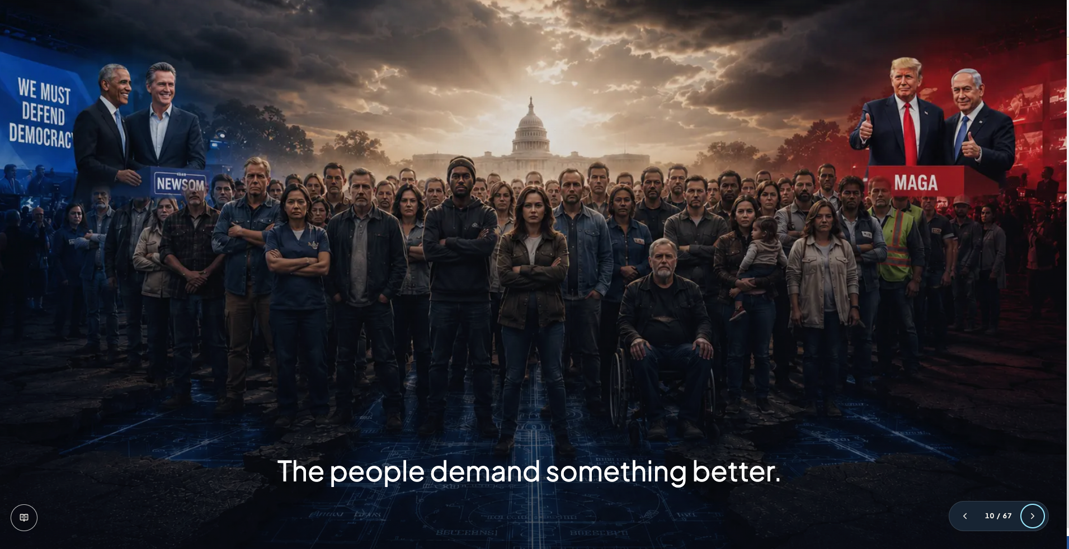

[GEORGE]
Personal, direct. Addressing Shawn Ryan.
I'm not asking you to duplicate a lifetime of dedication like Charlie did.
I'm asking for three hours of your undivided attention.
Because I want you to see what becomes possible when we combine the raw distribution power of a podcast—
with a strong strategy,
the right operational tools,
intelligence,
and people who share a common purpose.
Not simply to start another conversation.
But to put a series of actions into motion.
To demonstrate through execution what America First can mean.
And through the results we achieve—
build the foundation for the movement and new political party we envision.

[EDITOR CUE — JEETU: THREE-HOUR INVITATION]
Introduce a restrained visual progression:
ON-SCREEN TEXT ONLY — NO VOICEOVER
DISTRIBUTION → STRATEGY → TECHNOLOGY → EXECUTION
As George describes the longer-term ambition, transition briefly to:
PLATFORM → PROVEN RESULTS → MOVEMENT
IMPORTANT: Do not reveal the platform's name, logo, operating-system interface, manifesto, or future political-party identity.
Those elements will be formally introduced in subsequent chapters.

[GEORGE]
Controlled, confident. Final declaration.
TPUSA was a turning point.
This platform is what comes next.
And it starts right here, today.

[EDITOR CUE — JEETU: FINAL DECLARATION]
Return to the original 1776–2026 graphic.
Allow a brief pause between each of George's three statements.
As George says:
“This platform is what comes next.”
Display:
THIS PLATFORM IS WHAT COMES NEXT.
Hold through the final words:
“And it starts right here, today.”
Allow a short musical resolution, then transition into the following slide.
Do not reveal the platform's identity at this stage.

END OF SLIDE — FINAL PRODUCTION SCRIPT

SLIDE 3
[NARRATOR] (Deep, minimal, deliberate)
Editor: Try showing a glimpse of the triangle, current slide 28 as he’s speaking; show the triangle, do not include the very bottom layer: Technocratic Nationalism.
There are a lot of problems, and we will get into them, because you need to be sure we understand them, if we are to create change together.

[GEORGE] (Building from conviction)
Because we have been lied to.
And now we understand that we cannot be United if we cannot even protect our children.
Editor: Add “Children” to the top of the triangle when George says the word.

SLIDE 4
No Voiceover
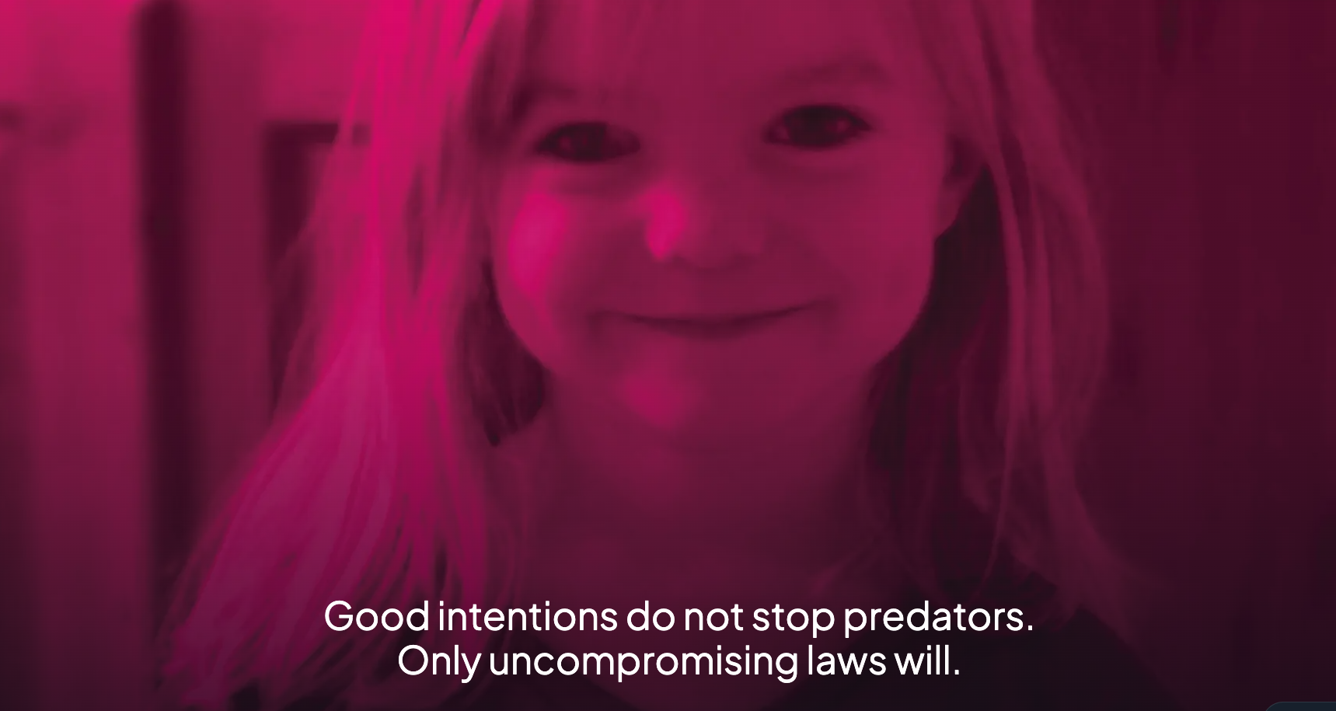

[GEORGE] (Building from conviction)
And through a podcast—
This podcast—
I will show you how we can deliver those laws.

[EDITOR CUE — JEETU: CLOSING VOICEOVER]
Keep the existing image on screen as George begins speaking.

SLIDE 5 — OUR AGENDA
Question: Should we remove the sentence under each section title?

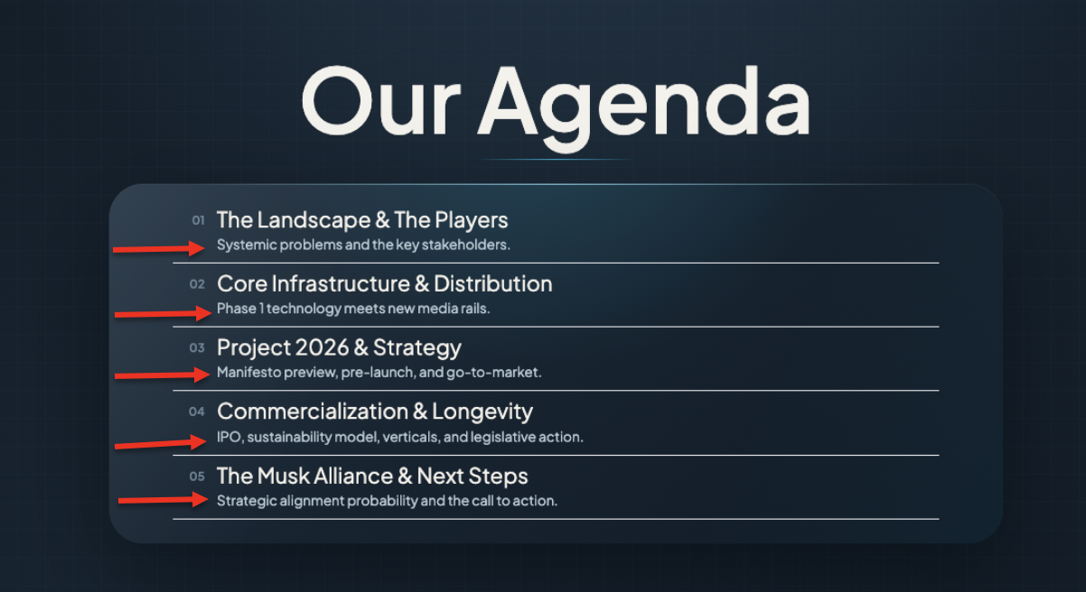

[GEORGE]
Our agenda.
[NARRATOR]
First—
The Landscape.
What is broken, what is changing, and why the current system is no longer enough.
Then—
The Architecture.
The technology, infrastructure, legislation, media, trust, and distribution required to build something different.
Then—
The Alliance.
The people and companies capable of moving each piece.
And finally—
The Musk Conversation.
Where everything that survives scrutiny comes together—
and the next phase begins.

SLIDE 6 — THE LANDSCAPE, THE PLAYERS & THE PROBLEMS
ON-SCREEN FOCUS
PROBLEMS — INSULATION & NOISE
[NARRATOR] (Deep, grave, establishing focus)
Start with what people actually live with.
Public safety.
Housing.
Healthcare.
Education.
The border.
The cost of living.
Whether these pressures are intentional or simply the result of systems that no longer work well—
the effect is the same.
Millions of people are consumed by the problems directly in front of them—
while many of the decisions shaping those problems are made somewhere else.
And there is evidence that raises a larger question about influence.
A major study of 1,779 U.S. policy issues found that economic elites and organized business interests had substantial independent effects on government policy—
while average citizens had little or no independent influence in the model.
That does not prove every decision is controlled from above.
But it does force a serious question:
How much agency does the average citizen actually have over the policies shaping their life?

[GEORGE] (Sharp, controlled)
Let’s take a look at the problems people actually feel.
Watch Insulation & Noise.
VIDEO Plays

Remove:
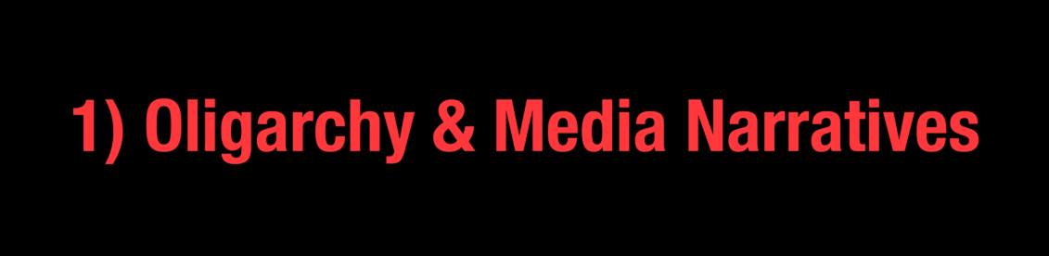
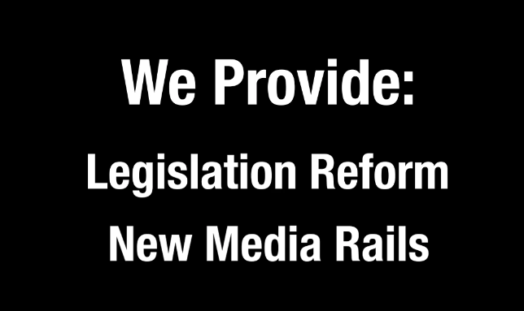

Remove:
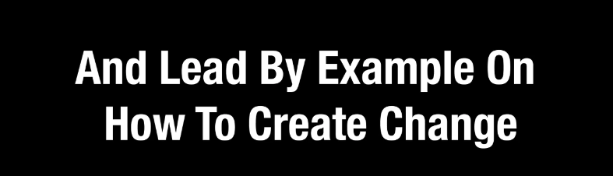

Replace:
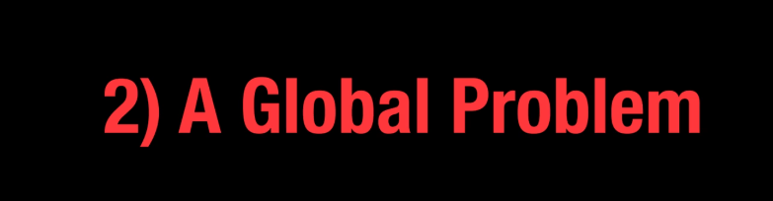
With: Global Demand
Do not sho: 2)

Remove: 3) from below:
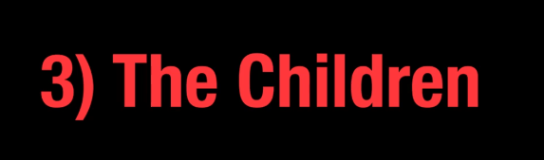

Remove:
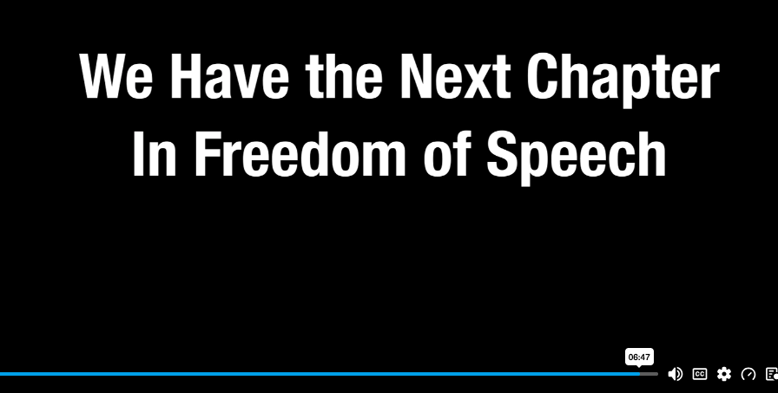
Add:
We Are the Evolution to Freedom of Speech

Finish the video here.

Continue with George
[GEORGE] (Sharp, controlled)
What you just saw is the world most people experience.
The problems directly in front of them.
This insulation and noise is created to keep the people occupied while even greater problems are orchestrated for power, control, and profit.

[NARRATOR] (Deep, grave, establishing focus)
But there is another layer.
The systems that shape what becomes possible in the first place.
The largest decisions affecting a nation are rarely made around one issue—
or by one institution.
They emerge from overlapping systems of:
capital—
technology—
defense—
finance—
politics—
media—
law—
and geopolitics.
Sometimes those interests align.
Sometimes they compete.
Sometimes they collide.
And ordinary citizens are often left living with the consequences—
without ever having participated in the decision.

[GEORGE] (Controlled, intriguing)
So now we go beneath the noise.

Bring in slide as George says it

SLIDE 7 — BENEATH THE NOISE
ON SCREEN
BENEATH THE NOISE
An investigation into the systems operating above everyday politics.
01 — POWER
02 — THE LONG GAME
03 — NETWORKS
04 — GLOBAL INCENTIVES
Short Pause before his voiceover starts
[GEORGE] (Controlled, intriguing)
Not through one theory.
Not through one institution.
And not through one person.
We are going to examine different centers of power—
how influence is built—
how it is sustained—
how networks form—
how incentives intersect—
and what happens when those forces begin operating at national and global scale.
Because if we want to build something capable of changing the future—
we first have to understand the systems already shaping it.
This is—
Beneath the Noise.
VIDEO PLAYS — BENEATH THE NOISE // 01

SLIDE 8 — BENEATH THE NOISE // 01
THE COMPETITION FOR POWER
[NARRATOR] (Analytical, documentary pacing)
The preceding argument describes a competition among three enormous centers of influence.
The Military Industrial Complex—
defense—
national security—
and decades of government spending.
The Financial Industrial Complex—
capital—
banking—
debt—
markets—
and the institutions that finance governments and industry.
And an emerging Technology Industrial Complex—
AI—
robotics—
data—
energy—
advanced manufacturing—
and digital infrastructure.
The thesis is not that one of these systems controls everything.
It is that power increasingly moves between them.
Capital follows opportunity.
Technology changes what is strategically possible.
Government determines where enormous resources can flow.
And as the next economic era takes shape—
technological power may increasingly challenge institutions that dominated the last one.

[GEORGE] (Measured, increasingly intrigued)
Whether every part of that thesis proves correct isn’t the point.
The more important question is:
How did a relatively small group of technology leaders become powerful enough to operate at this level in the first place?
They didn’t arrive there overnight.
The companies—
the capital—
the networks—
the government relationships—
the infrastructure—
were built over decades.
So before we ask where this concentration of technological power may be going—
we need to understand how it was created.
Because power rarely appears suddenly.
It compounds.
And some of the most consequential people shaping the future—
have been playing the long game for a very long time.

SLIDE 9 — BENEATH THE NOISE // 02
THE LONG GAME
[NARRATOR] (Analytical, documentary pacing)
Go back far enough—
and many of the technologies now shaping national power were once dismissed as unrealistic.
AI at scale.
Reusable rockets.
Autonomous systems.
Private space infrastructure.
Software transforming government.
Entire industries rebuilt around technology.
Some of the people leading that transition spent decades pursuing ideas others thought were impossible.
So if we want to understand their influence today—
we first have to understand their persistence.
Let’s go back.
PLAY VIDEO

[GEORGE] (Measured, increasingly intrigued)
Critics dismissed the vision.
The technology failed.
Capital disappeared.
Timelines slipped.
But they stayed in the arena.
They built.
Failed.
Raised capital.
Lost capital.
Rebuilt.
And tried again.
Over time—
ideas that once lived at the margins moved into:
industry—
defense—
government—
capital markets—
and national infrastructure.
Persistence became capability.
Capability became scale.
And scale became influence.

[NARRATOR] (Analytical, documentary pacing)
That is the long game.
Companies once fighting to prove they belonged—
are now helping build systems governments depend upon.
So these ideas are no longer sitting on the sidelines.
They are becoming part of the machinery of the state.
Which raises the next question:
What do they believe the future should look like?

[GEORGE] (Measured, increasingly intrigued)
But there is another question that matters even more:
If we are not satisfied with the present—
and we do not like where the future is going—
why accept it as inevitable?

Why not understand the system—
build something better—
and change it?

SLIDE 10 — BENEATH THE NOISE // 02
TECHNOLOGICAL POWER
[NARRATOR] (Analytical, macro-strategic)
Don’t get lost in the personalities.
Look at what they represent.
Technology is becoming one of the defining sources of economic—
military—
and geopolitical power.
Across these leaders, a common mandate begins to emerge:
Build the technologies that will define the next century.
AI.
Robotics.
Advanced manufacturing.
Energy.
Digital infrastructure.
Then accelerate them.
Remove barriers.
Mobilize capital.
Expand domestic capability.
And increasingly—
align government and industry to move faster.
This is not simply a technology agenda.
It is a national-power strategy.

[GEORGE] (Passionate, visionary)
But now imagine something bigger.
What if the public were not merely watching that future arrive—
but had a meaningful role in shaping it?
Where technology is deployed.
What safeguards govern it.
What institutions are built around it.
And who ultimately benefits.
Because technological progress without public agency leaves citizens as spectators.
We are proposing something different: participation in the architecture itself.

Not stopping progress.
Helping shape it.

If America’s ambition is technological leadership—
then the question is not simply:
What can we build?
It is:
Who helps decide what gets built—
under what rules—
and for whose benefit?

[NARRATOR] (Dropping pitch; investigative intrigue)
And that leads to the harder question.
If the technology exists—
the capital exists—
the talent exists—
and powerful institutions already believe dramatic change is necessary—
why is changing the system itself still so difficult?
Because technology is only one layer of power.
Behind public policy sits another architecture:
donors—
foundations—
advocacy organizations—
political networks—
media—
legal institutions—
private capital—
and competing centers of influence.
Technology may determine what is possible.
But networks often determine what becomes funded, permitted, adopted, and institutionalized.
Which brings us to another form of power:
THE NETWORK.

SLIDE 11 — BENEATH THE NOISE // 03
THE POWER OF NETWORKS
[GEORGE] ( investigative)
Technology companies show how products—
capital—
and innovation—
can compound power.
And sometimes they help the military
Our police
and keep us safe at home.

[NARRATOR] (Analytical, macro-strategic)
Political influence can compound too.
Over decades—
foundations—
donors—
advocacy organizations—
legal groups—
media—
research institutions—
and political networks
can form an ecosystem capable of shaping public debate—
public policy—
and institutional priorities.
One of the most debated examples is the network associated with George Soros and the Open Society ecosystem.
Supporters describe it as philanthropy supporting democracy—
civil society—
and human rights.
Critics describe something more consequential:
a long-term architecture of political and institutional influence.
This segment examines that argument.
VIDEO PLAYS — BENEATH THE NOISE // 03
THE POWER OF NETWORKS

[GEORGE] (Controlled)
Whatever conclusion you draw about Soros himself—
the larger lesson matters.
Networks compound power.
Capital alone is powerful.
But capital connected to:
Editor: Bring on screen the below as they are spoken
institutions—
media—
law—
politics—
research—
and organized action—
becomes something much larger.
It becomes DURABLE
Distributed.
And capable of influencing outcomes long after any single election—
or any single individual—
is gone.

[NARRATOR] (Low, investigative)
Power is not only held by people.
It is embedded in networks.
And this is where the balance of power can change.
Because historically—
building influence at this scale took decades.
EDITOR: SHOW CLIPS FROM THE GEORGE SOROS MOVIE
But what happens when technology compresses that timeline?
What happens when citizens can:
organize—
understand policy—
assemble experts—
build support—
and move lawful reform
faster than traditional institutions were designed to operate?

[GEORGE] (Controlled)
Then the advantage of the established network begins to weaken.
Not because one power structure is replaced by another—
but because citizens gain infrastructure of their own.

[NARRATOR] (Low, investigative)
And once those networks begin crossing borders—
capital—
policy—
technology—
and institutions—
the scale changes again.
Because above domestic influence—
the competition becomes global.
And so does the opportunity.

[GEORGE] (VISIONARY)
Because our vision is global too.

SLIDE 12 — BENEATH THE NOISE // 04
GLOBAL INCENTIVES
[NARRATOR] (Grave, authoritative; widening the lens)
EDITOR: We may be able to do something creative with the words below
Political networks are one layer.
But above domestic politics sits something larger.
Energy.
Capital.
War.
Trade.
Technology.
Religion.
Geopolitics.
And when those systems collide—
ordinary people absorb the consequences.
Fuel.
Food.
Housing.
Interest rates.
Jobs.
Savings.
Supply chains.
Everything connects.

Andrei Jikh lays out four competing explanations for how some of these forces may be interacting:
Iranian economic warfare.
Transnational capital.
American energy strategy.
And a geopolitical interpretation shaped by religious prophecy.
Different actors.
Different motives.
Different theories.
But one question connects them:
What happens when powerful systems begin maximizing their own interests at the same time?
And what happens to ordinary people when those incentives collide?
Inflation.

Maybe a chart?
Debt.
Energy.
Markets.
Jobs.
Household security.
This is not one prediction.
It is a map of competing incentives.
And the consequences when they converge.
Let’s watch.
VIDEO PLAYS — BENEATH THE NOISE // 04
GLOBAL INCENTIVES

SLIDE 13 — BENEATH THE NOISE: WHAT WE LEARNED
ON SCREEN
VISIBLE PROBLEMS
Remove:
BENEATH THE NOISE
↓
01 — COMPETING CENTERS OF POWER
↓
02 — TECHNOLOGICAL POWER
↓
03 — NETWORKED INFLUENCE
↓
04 — GLOBAL INCENTIVES
↓
THE QUESTION
How do citizens gain meaningful agency over what comes next?

[NARRATOR] (Deep, measured; simplifying everything that came before)
Pull back.
What have we actually seen?
At the surface—
the problems people live with every day.
Go beneath them—
and the picture changes.
Competing centers of power.
Technology becoming a source of national power.
Networks capable of compounding influence over decades.
And global systems—
capital—
energy—
war—
trade—
technology—
and geopolitics—
operating according to different incentives.
Different players.
Different motives.
Different theories.
But one recurring reality:
many of the decisions shaping people’s lives happen at levels where ordinary citizens have very little direct influence.

[GEORGE] (Controlled; turning diagnosis into purpose)
And that is why we went beneath the noise.
Not simply to expose problems.
To identify what is missing.
If capital can organize—
if industries can organize—
if political networks can organize—
if technology can organize—
then the people need infrastructure capable of organizing too.
Not merely to complain.
To understand.
To verify.
To coordinate.
To participate.
And ultimately—
to act.

[GEORGE] (Simple. Final.)
Because only action can save our republic.

[NARRATOR] (Pause)
So the question becomes:
How do citizens gain meaningful agency over what comes next?

[GEORGE] (Simple. Final.)
We build it.

SLIDE 14 — FIVE PILLARS
HARD-WIRED TO ACTION
[GEORGE] (Decisive)
Five pillars.
Hard-wired to action.

[NARRATOR] (Building from diagnosis into solution)
If citizens are going to meaningfully shape what comes next—
We must step outside their walls—and build something stronger.
Something that can be tested.
Proven.
Distributed.
Scaled.
And withstand the real world.

Editor: Bring in the Slide Creatives below
when George speaks: Technology, Connectivity….Powerful Ecosystem
[GEORGE]
Look at the board.
Technology.
Connectivity.
Sustainability.
Media Rails.
A Powerful Ecosystem.

Individually—
they are capabilities.
Connected—
they become infrastructure.

Technology creates capability.
Connectivity creates scale.
Sustainability creates longevity.
Media creates understanding and distribution.
And the ecosystem brings together the people—
capital—
institutions—
and expertise
required to turn opportunity into action.
Because—
action is the ultimate currency of freedom.

[NARRATOR] (Momentum building)
This is the shift.
From problems—
to alternatives.
From frustration—
to participation.
From voice—
to consequence.

[GEORGE] (Strong, controlled)
Every pillar serves one objective:
Editor: Bring in a strong creative here
shorten the distance between public voice and lawful action.
Deploy.
Integrate.
Build new rails.
Scale.
Technology becomes the tool.
Connectivity becomes reach.
Media becomes understanding.
The ecosystem becomes leverage.
And citizens become participants—
helping shape what comes next.
The blueprint is no longer theoretical.
It is ready for action.
Now we build.

SLIDE 15 — INSPIRATION VIDEO

Video Jeetu, improve on the editing, where it splices into President Trump (listen to where my voice finishes before he comes in) Try to not have his mouth open at the very end.

SLIDE 16— FOUNDER PRINCIPAL

[GEORGE] (Sharp, intense, commanding the room)
The next great systems won’t just run on code—they’ll reshape institutions, anchor in the physical world, and restore trust through unity, transparency, and design.

SLIDE 17

NO VOICEOVER

SLIDE 18

[NARRATOR] (Deep, revolutionary tone, building intense gravity)
Viral Fusion.
Connecting voices. Powering change.

Editor: Make this change on the home page too.

SLIDE 19
[NARRATOR] (Cinematic, profound pacing)
Our Mission:
Return power to the people by rebuilding public institutions with technology that unlocks civic trust and economic value at scale.
Our Vision:
Make the public will impossible to ignore by turning raw civic engagement into a data-driven engine for structural reform.

SLIDE 20 The Problems — WE’RE SOLVING
[NARRATOR] (Deep, grave, exposing the crisis)
Look at the board.
Public safety.
Housing.
Healthcare.
Education.
Jobs.
Energy.
Infrastructure.
Civil rights.
Immigration.
Government accountability.
Technology.
These are not separate problems.
They are interconnected systems shaping how people live.
And across too many of them—
Americans increasingly question whether the institutions built to serve the public are still producing the outcomes people need.
At the same time—
technology is becoming more powerful.
More connected.
More intelligent.
More capable of shaping:
speech—
identity—
access—
information—
and behavior.
That creates a fundamental choice.
Does technology become another layer of control—
or a tool that gives citizens greater agency?

[GEORGE] (Sharp, controlled)
That is where Technocratic Nationalism begins.
Not by rejecting technology.
By putting technological power in service of the citizen.
Technology.
Connectivity.
Verification.
Transparency.
Decentralized infrastructure.
Accountability.
The same tools capable of concentrating power—
can also be used to distribute it.
To strengthen sovereignty.
Improve public systems.
Protect critical infrastructure.
Make government accountable.
And give citizens a more direct—
verifiable—
meaningful role in the institutions shaping their lives.
The principle is simple:
Technology should increase the power of the citizen—
not the power over the citizen.
And that leads to the objective:
Use technological power—
without surrendering civic power.

EDITOR NOTE — Finish on screen:
TECHNOCRATIC NATIONALISM
add the subtitle:
Technology in service of citizen sovereignty.

SLIDE 21

[NARRATOR] (Deep, grave, exposing the crisis)
Connectivity.
Tools.
Uncompromised Decision-Making.
[GEORGE] (Sharp, intense focus, throwing down a gauntlet)
We keep it simple:
A stronger Republic—powered by proof, voice, and immediate action.

Lets remove the word “Immediate” from the slide and voiceover?

SLIDE 22 — CIVIC OPERATING SYSTEM
AUTHENTICATING THE FUTURE OF REPRESENTATION
Editor: This is an example only, you may be able to further improve
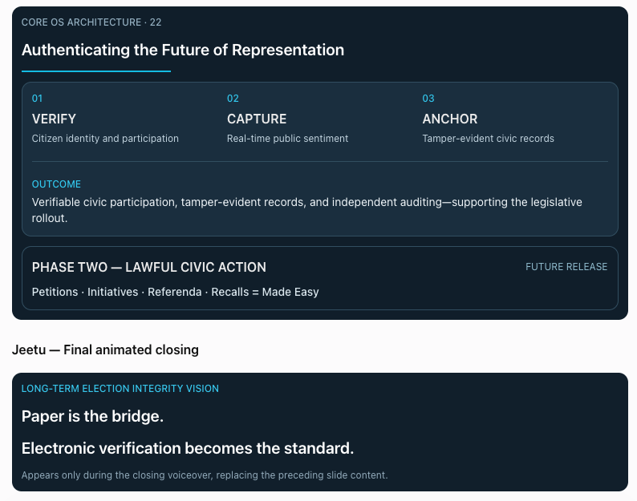
See below, this has changed.

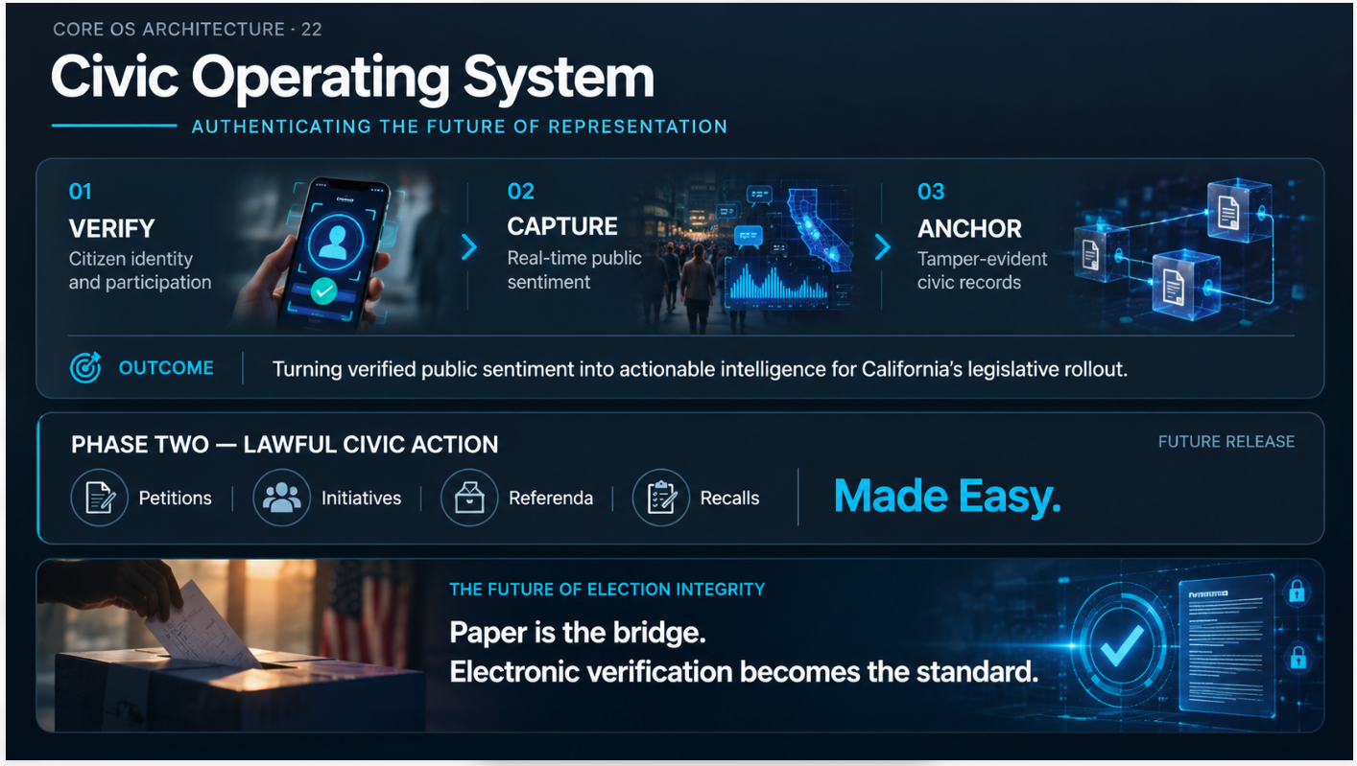

SLIDE 22 — CIVIC OPERATING SYSTEM
AUTHENTICATING THE FUTURE OF REPRESENTATION

[NARRATOR]
Measured, analytical. Introducing the architecture.
The Civic Operating System begins with three core functions.
Verify the citizen.
Capture verified participation and real-time public sentiment.
And—
Anchor defined events through tamper-evident digital records.
Creating an auditable record of public participation.

[EDITOR CUE — JEETU: CORE OS ARCHITECTURE]
Reveal the three functions sequentially as the Narrator introduces them.
01 — VERIFY
Citizen identity and participation
02 — CAPTURE
Real-time public sentiment
03 — ANCHOR
Tamper-evident civic records
After ANCHOR, reveal the Outcome statement below the three functions.
ON-SCREEN TEXT ONLY — NO VOICEOVER
OUTCOME
Turning verified public sentiment into actionable intelligence for California's legislative rollout.
Production direction: Preserve the dark navy background, cyan highlights, and three-column arrangement.
Keep the Outcome statement within the primary architecture panel rather than creating another panel.
Show a simple visual relationship between the three functions. Do not introduce a detailed blockchain or cryptography demonstration here; those concepts receive fuller treatment later.

[NARRATOR]
Building from participation to action.
Phase Two transforms verified participation into tools supporting lawful civic action.
Petitions.
Initiatives.
Referenda.
Recalls.
Easier to organize.
Easier to verify.
Harder to manipulate.

[EDITOR CUE — JEETU: PHASE TWO]
Reveal the second panel beneath the operating-system architecture.
ON-SCREEN TEXT ONLY — NO VOICEOVER
PHASE TWO — LAWFUL CIVIC ACTION
FUTURE RELEASE
Petitions · Initiatives · Referenda · Recalls
Made Easy.
Give Made Easy greater prominence using the existing cyan accent.
Production direction: Phase Two is a future software release. The initial California legislative rollout will use the available Civic Operating System capabilities and an accompanying lawful campaign process; do not imply Phase Two's complete automation is already operational.
Keep the Phase Two panel visually smaller than the primary architecture panel.

[GEORGE]
Controlled, resolute. Establishing the governing principle.
And as this technology evolves, one principle remains.
Technology must strengthen election integrity—not replace the safeguards protecting it.
That means:
Paper ballots for the physical record—
Secure digital systems for integrity and traceability—
And independent parallel audits for accountability.
The goal is not blind trust.
It is verifiable trust.

[EDITOR CUE — JEETU: ELECTION-INTEGRITY LAYERS]
Introduce a concise, temporary graphic rather than another permanent slide panel.
ON-SCREEN TEXT ONLY — NO VOICEOVER
PAPER RECORD → DIGITAL VERIFICATION → INDEPENDENT AUDIT
Reveal each safeguard as George mentions it.
Use a paper ballot, a conceptual cryptographic verification interface, and an independent audit symbol.
Production direction: Present these as complementary safeguards in the proposed future architecture—not as an already approved or certified election system.
Do not imply that a digital ledger by itself establishes the legitimacy of an election.
Fade the temporary graphic out before the Narrator introduces the longer-term vision.

[NARRATOR]
Forward-looking. Introducing the longer-term vision.
And paper is not the ideology.
Verification is.
One day, technology may demonstrate even higher standards of security, privacy, accessibility, and auditability.
But those capabilities must be tested.
Independently evaluated.
And proven before they can responsibly replace existing safeguards.
The objective isn't simply to digitize the old system.
It's to build something better.

[EDITOR CUE — JEETU: TRANSITION TO THE FUTURE]
Gradually reduce the complexity of the visuals.
Use a restrained progression from the current paper-and-digital model toward a conceptual next-generation verification system.
Do not show paper records disappearing as though electronic-only voting has already been authorized or demonstrated to be superior.
As the Narrator concludes “It's to build something better,” begin fading out the earlier architecture content.
Prepare the final full-screen statement.

[GEORGE]
Controlled, visionary. Final declaration.
And that's the future we're designing for.
Paper is the bridge.
Electronic verification becomes the standard.

[EDITOR CUE — JEETU: FINAL VISUAL REVEAL]
Transition to a clean, full-screen visual in the existing navy and cyan style.
ON-SCREEN TEXT ONLY — SYNCHRONIZED WITH GEORGE
THE FUTURE OF ELECTION INTEGRITY
Paper is the bridge.
Electronic verification becomes the standard.
Timing:
As George says “And that's the future we're designing for,” reveal the heading.
As he says “Paper is the bridge,” reveal the first statement.
As he says “Electronic verification becomes the standard,” reveal the second statement.
Hold the completed visual for approximately 2–3 seconds.
Use subtle typography animation, not another technical montage.
Transition directly into Slide 23 — Hard-Wired Civic Connectivity.

FINAL ON-SCREEN CONTENT — SLIDE 22

PRIMARY SLIDE
CORE OS ARCHITECTURE · 22

AUTHENTICATING THE FUTURE OF REPRESENTATION
01 — VERIFY
Citizen identity and participation
02 — CAPTURE
Real-time public sentiment
03 — ANCHOR
Tamper-evident civic records
OUTCOME
Turning verified public sentiment into actionable intelligence for California's legislative rollout.

PHASE TWO — LAWFUL CIVIC ACTION
FUTURE RELEASE
Petitions · Initiatives · Referenda · Recalls
Made Easy.

FINAL ANIMATED CLOSING
THE FUTURE OF ELECTION INTEGRITY
Paper is the bridge.
Electronic verification becomes the standard.

FINAL PRODUCTION NOTES — JEETU
Design: Retain the original dark navy palette, cyan highlights, rounded panels, and bold white typography.
Visual hierarchy: The primary operating-system functions should occupy most of the slide. Phase Two should remain clearly separate and smaller.
Animation: Reveal the three operating-system functions in sync with the Narrator. Introduce Phase Two afterward. Use only one brief temporary election-safeguards graphic before transitioning to the final closing statement.
Timing: Keep animations synchronized with the voiceover. Avoid additional pauses except for the 2–3-second hold at the end.
Technical accuracy: Distinguish verified civic sentiment from official election results. The long-term electronic-verification vision is a proposed future direction requiring independent validation and appropriate legal authorization.
Transition: The full-screen election-integrity vision should give way to Slide 23's physical infrastructure presentation without another extended opening animation.

END OF SLIDE 22 — FINAL PRODUCTION SCRIPT

SLIDE 23 — PHYSICAL INFRASTRUCTURE
HARD-WIRED CIVIC CONNECTIVITY

[GEORGE]
Strong, confident.
We are at the beginning of a technological revolution.

[NARRATOR]
Measured, expanding from digital to physical infrastructure.
Digital participation becomes more powerful when it has a physical presence.
A distributed network of intelligent, connected displays—
positioned where people already live, work, travel, and gather.
Retail.
Transportation.
Commercial spaces.
And communities.
Not simply screens.
Physical access points into the civic ecosystem.

[EDITOR CUE — JEETU: PHYSICAL DISTRIBUTION]
Reveal the first row of the slide.
01 — DISTRIBUTION
A connected physical network reaching people in high-traffic locations.
Show a concise sequence of connected displays across retail, transportation, commercial, and community environments.
End with a wider view of the proposed network.

[GEORGE]
Executive, strategic. Establishing ownership and commercial value.
And this is where ownership changes everything.
By controlling the physical infrastructure—
we control the environment.
The distribution.
The media.
The integration.
And the user experience.
We control the narrative environment through our own media network.
And that creates something extraordinary.
A commercial engine built around the civic layer.
Advertising.
Original programming.
Enterprise services.
Brand partnerships.
And future AI applications.

[EDITOR CUE — JEETU: OWNERSHIP & COMMERCIAL MODEL]
Reveal the second row.
02 — COMMERCIAL SUSTAINABILITY
Media, advertising, enterprise services, and partnerships help finance the network.
Show original programming and commercial content distributed through the connected displays.
Briefly illustrate revenue supporting network operations and expansion.
Preserve the distinction between the proposed network and currently operating assets.

[NARRATOR]
Measured, building commercial significance.
And that changes the economics.
The infrastructure doesn't have to depend entirely on donations—
grants—
or the next political cycle.
Commercial revenue helps maintain the network.
Expand it.
Upgrade it.
And sustain its public-facing mission.

[GEORGE]
Strong, deliberate.
That is the model.
Civic infrastructure with its own engine for survival.

[NARRATOR]
Measured, transitioning toward Slide 24.
But sustainability alone isn't enough.
The system must also withstand changes in the platforms it depends upon.
That requires resilience.

[EDITOR CUE — JEETU: RESILIENCE]
Reveal the third row.
03 — RESILIENCE
Distributed infrastructure designed for long-term continuity.
Show the physical network remaining available through its independently operated infrastructure, subject to its actual technical dependencies.
Do not introduce the complete Sovereign Parallel Network architecture here. That belongs in Slide 24.

[GEORGE]
Controlled, consequential. Final declaration.
We're not building a temporary media campaign.
We're building a permanent physical foundation.
Connected to our digital systems.
Supported by commercial revenue.
And designed to endure.
Infrastructure capable of supporting a new civic era.

[EDITOR CUE — JEETU: FINAL CLOSING]
Reveal the bottom statement.
THE GOAL
Create a permanent physical foundation for civic participation—distributed, commercially sustainable, and resilient.
Hold the completed network graphic briefly.
Transition directly to Slide 24, The Strategic Alliance.

UPDATED ON-SCREEN CONTENT — SLIDE 23
PHYSICAL INFRASTRUCTURE

HARD-WIRED CIVIC CONNECTIVITY
Anchoring the Digital Pulse into Physical Assets
01 — DISTRIBUTION
Connected displays in high-traffic locations.
02 — COMMERCIAL SUSTAINABILITY
Media, advertising, enterprise services, and partnerships finance the network.
03 — RESILIENCE
Distributed infrastructure designed for long-term continuity.

THE GOAL
A permanent physical foundation for civic participation—commercially sustainable and built to endure.

END OF SLIDE 23 — RECOMMENDED CONDENSED PRODUCTION SCRIPT

SLIDE 24 — DISTRIBUTION & RESILIENCE
THE STRATEGIC ALLIANCE

[NARRATOR]
Measured, building scale.
The physical network establishes our presence.
But reaching the world requires something more.
Distribution at scale.
Without sacrificing independence.

[GEORGE]
Executive, strategic.
Imagine combining X's global distribution—
with xAI's intelligence.
Real-time information.
Public engagement.
AI-powered applications.
An extraordinary opportunity to accelerate adoption worldwide.
That's the strategic alliance I want to explore.

[EDITOR CUE — JEETU: X / xAI — ACCELERATION]
Reveal the first column of the slide.
01 — X / xAI
ACCELERATION
Global distribution + AI intelligence.
Use a brief visualization showing global media distribution and AI-supported applications.
Present the alliance as proposed, not confirmed.

[GEORGE]
Controlled, decisive. Introducing the counterbalance.
But acceleration without resilience creates dependency.
And there is one principle we cannot compromise.
No civic infrastructure this important should have a single point of failure.
Not one company.
Not one platform.
Not even an extraordinary one.
That's why we're designing a second rail.
A Sovereign Parallel Network.
Independent.
Verifiable.
Redundant.
Imagine a country restricts access to X.
Its conventional social-media services become unavailable.
But the civic operating system continues.
Citizens can still communicate.
Organize.
Develop proposals.
And pursue lawful change through the tools available to them.
Because these are two different capabilities.
One distributes information at extraordinary scale.
The other preserves an independent pathway for civic participation.
Not to compete with X.
To protect our independence.

[EDITOR CUE — JEETU: SOVEREIGN PARALLEL NETWORK]
Reveal the second column.
02 — SOVEREIGN PARALLEL NETWORK
RESILIENCE
Independent continuity + verification.
Show the proposed civic network operating alongside X/xAI.
VISUAL SEQUENCE — NORMAL OPERATIONS
Both networks appear connected and available.
X/xAI supports media distribution and AI-assisted applications.
The sovereign network supports its own civic records, authorized communications, and participation services.
VISUAL SEQUENCE — DISTRIBUTION RESTRICTION
Show a hypothetical country restricting conventional X social-media access.
The X distribution channel becomes unavailable.
The sovereign civic network remains accessible in the demonstration.
Show the following functions continuing:
ON-SCREEN TEXT ONLY — NO VOICEOVER
COMMUNICATE → ORGANIZE → DEVELOP PROPOSALS → LAWFUL ACTION
Conclude with:
SOCIAL DISTRIBUTION RESTRICTED
CIVIC PARTICIPATION CONTINUES
Production direction: Illustrate separate operational capabilities, not an undisclosed method of bypassing restrictions.
This is a proposed architecture. The scenario assumes independent hosting, authentication, communications, and legally permitted operation. Do not depict continuity as guaranteed or already demonstrated.

[NARRATOR]
Measured, widening globally.
And as this architecture expands beyond America—
every nation will have its own laws.
Its own safeguards.
Its own implementation requirements.

[GEORGE]
Deliberate, resolute.
But the principle remains.
Lawful public participation should never depend on a single gatekeeper.
A government may restrict a distribution channel.
But that should not automatically eliminate the independent civic tools through which people communicate, organize, and pursue lawful change.
The objective is global reach without surrendering the independence of the civic system.

[NARRATOR]
Measured, building toward the conclusion.
The objective is to shorten the distance between—
Voice.
Verification.
And lawful action.
At the speed of the digital age.

[GEORGE]
Strong, deliberate. Final declaration.
X and xAI offer acceleration.
The sovereign network protects continuity.
One helps us reach the world.
The other helps us endure.
Together—
Scale without dependency.

[EDITOR CUE — JEETU: FINAL CONVERGENCE]
Bring both columns together using the existing visual connector.
ON-SCREEN TEXT ONLY — NO VOICEOVER
TOGETHER: SCALE WITHOUT DEPENDENCY
Keep both network capabilities visible as George delivers the closing lines.
Briefly highlight:
ACCELERATION + RESILIENCE
Return the emphasis to:
SCALE WITHOUT DEPENDENCY
Hold for approximately 2 seconds after George's final line, then transition to Slide 25.
Avoid a second technical animation during the closing.

FINAL ON-SCREEN CONTENT — SLIDE 24
CORE OS ARCHITECTURE

THE STRATEGIC ALLIANCE
A Global Distribution Pathway to Scale

01 — X / xAI
ACCELERATION
Global distribution + AI intelligence.

02 — SOVEREIGN PARALLEL NETWORK
RESILIENCE
Independent civic continuity + verification.
TOGETHER: SCALE WITHOUT DEPENDENCY
THE BOTTOM LINE
From verified public participation to lawful action—at digital-age speed.

END OF SLIDE 24 — FINAL PRODUCTION SCRIPT
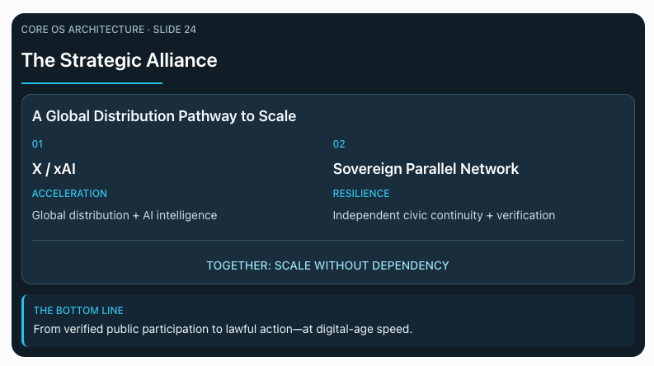
A little busy
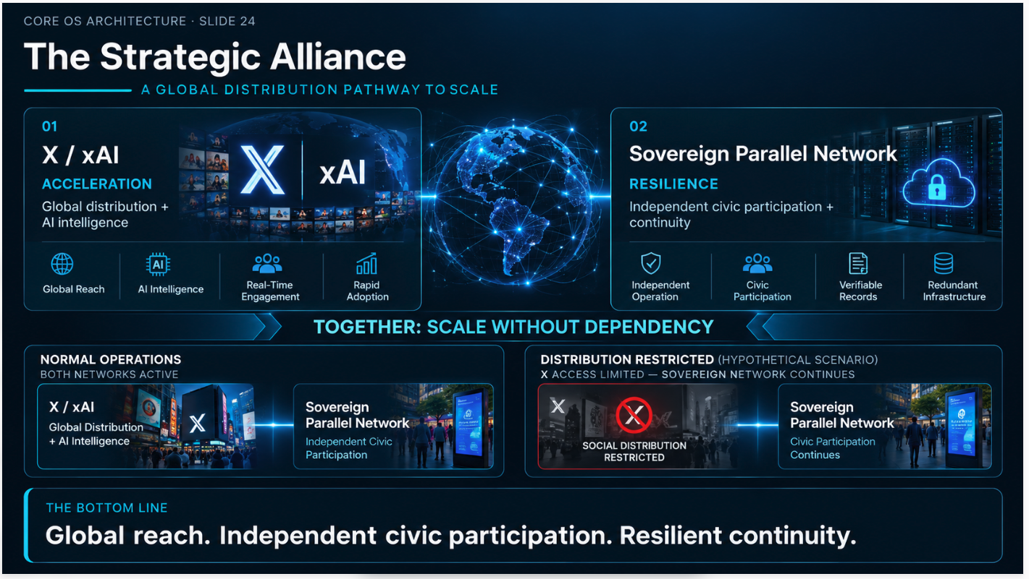

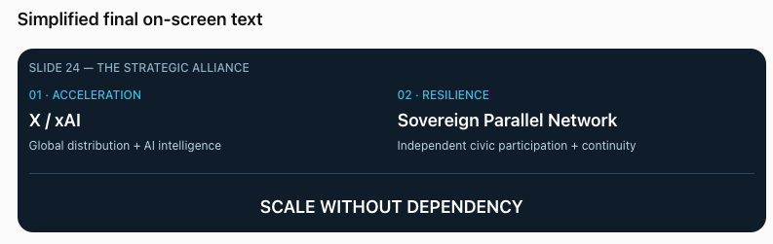

SLIDE 24 — ANIMATION & EDITING PLAN
SCENE 1 — X / xAI
Reveal the X/xAI panel during George's introduction of the proposed strategic alliance.
Emphasize global distribution and AI intelligence.
Do not display the sovereign panel yet.
SCENE 2 — SOVEREIGN PARALLEL NETWORK
As George says, “That's why we're designing a second rail,” introduce the Sovereign Parallel Network.
Display both capabilities side by side.
Keep the layout minimal.
SCENE 3 — HYPOTHETICAL DISTRIBUTION RESTRICTION
As George describes a country restricting conventional X services, dim the X distribution panel.
Keep the sovereign civic layer illuminated, illustrating its proposed independent operation.
Do not add a separate lower-half comparison graphic.
Show the scenario as hypothetical, with continuity dependent on lawful access and independent technical infrastructure.
SCENE 4 — FINAL CONVERGENCE
Restore the two-panel layout.
As George delivers the closing:
“One helps us reach the world.
The other helps us endure.
Together—
Scale without dependency.”
Connect the two panels with a restrained cyan animation.
Display:
SCALE WITHOUT DEPENDENCY
Hold for approximately 2 seconds, then transition to Slide 25.
PRODUCTION PRIORITY
Clean typography, subtle animation, one clear message at a time.
No additional icons, dense captions, or extended technical explanations.

SLIDE 25 — THE BLUEPRINT
ACTIONS. VERTICALS. ECOSYSTEM. VELOCITY.

[NARRATOR]
Cinematic, measured. Revealing the larger architecture.
Now pull back.
The Civic Operating System.
The physical infrastructure.
The media and distribution networks.
These are not separate ambitions.
They are components of a larger Blueprint.
Four engines.
Actions.
A pathway from verified public participation to lawful civic change.
Verticals.
New industries, services, and commercial opportunities built around the architecture.
Ecosystem.
The people, technology, capital, and partnerships required to execute.
And Velocity.
The ability to accelerate development, distribution, and adoption.

[GEORGE]
Controlled, deliberate. Establishing the larger vision.
Each has a purpose.
But the real opportunity is what happens when they begin working together.
We're not building another isolated application.
We're designing an architecture that can grow beyond any one product, company, or political moment.
And the question is no longer simply what the technology can do.
It's what we can accomplish when we begin bringing the right capabilities together.

[EDITOR CUE — JEETU: THE FOUR ENGINES]
VISUAL OBJECTIVE
Reveal the four foundational components of the Blueprint without demonstrating the complete flywheel yet.
Begin with the Blueprint title.
As the Narrator introduces each engine, reveal the corresponding quadrant.
01 — ACTIONS
Verified participation → Lawful action
02 — VERTICALS
New industries → Commercial expansion
03 — ECOSYSTEM
Capital → Technology → Partnerships
04 — VELOCITY
Intelligence → Distribution → Execution
Use restrained cyan illumination to introduce each quadrant.
When George says:
“But the real opportunity is what happens when they begin working together.”
Briefly illuminate the connections among the four components.
Do not animate the fully operating flywheel.
On George's final statement, hold the completed four-quadrant Blueprint.
PRODUCTION NOTES
Preserve the established dark navy background, cyan accents, bold typography, and restrained motion.
Keep the visual clean. The four quadrants are the primary creative element.
Do not introduce the complete Musk technology ecosystem or detailed potential guest relationships.
Do not add an IPO timeline or valuation target.

FINAL ON-SCREEN CONTENT — SLIDE 25
THE BLUEPRINT
ACTIONS. VERTICALS. ECOSYSTEM. VELOCITY.
01 — ACTIONS
Verified participation → Lawful action
02 — VERTICALS
New industries → Commercial expansion
03 — ECOSYSTEM
Capital → Technology → Partnerships
04 — VELOCITY
Intelligence → Distribution → Execution

[EDITOR CUE — JEETU: TRANSITION TO SLIDE 26]
Hold the completed four-quadrant Blueprint briefly.
Then gradually fade the individual components into darkness.
Let the connecting lines remain faintly visible.
Transition to a nearly black background.
Reveal only:
WHAT IF?
Do not introduce the guest names yet.
The next slide changes the question from what we're building to how a conversation might begin putting the strategy into motion.

END OF SLIDE 25 — FINAL PRODUCTION SCRIPT

SLIDE 26 — WHAT IF?
CAN A PODCAST BECOME AN EXECUTION ENGINE?

[GEORGE]
Quiet, personal. Building significance.
What if meaningful change doesn't begin inside government?
What if it begins here—with a conversation?
Think about Elon Musk.
Palmer Luckey.
Peter Thiel.
They've helped build companies that transformed industries.
But none of them did it alone.
It took extraordinary people.
Engineers.
Inventors.
Entrepreneurs.
And everyday people who wanted to be part of something they believed in.
People who wanted their work—and their lives—to have purpose.
People who believed in a vision—and helped make it real.

[EDITOR CUE — JEETU: THE PEOPLE BEHIND THE VISION]
Begin with a nearly black background.
Reveal:
WHAT IF?
As George introduces Musk, Luckey, and Thiel, briefly show authentic footage of the founders and their companies.
Shift the visual emphasis toward the people behind those businesses:
Engineers.
Researchers.
Manufacturing teams.
Inventors.
And everyday people contributing to a shared vision.
On George's line:
“People who wanted their work—and their lives—to have purpose.”
Show authentic footage of teams collaborating and building something together.
Keep the sequence human and grounded. Avoid a lengthy montage of founders or company logos.

[NARRATOR]
Measured, consequential. Establishing synergistic value.
Technology.
Manufacturing.
Distribution.
Individually, they create value.
Together, they can create something greater than the sum of their parts.
For their businesses.
For the people involved.
And potentially, for society.

[EDITOR CUE — JEETU: COMPLEMENTARY CAPABILITIES]
Show three distinct capabilities converging.
ON-SCREEN TEXT ONLY — NO VOICEOVER
TECHNOLOGY + MANUFACTURING + DISTRIBUTION
Then reveal:
NEW OPPORTUNITIES
Use restrained motion to show how combining complementary capabilities can unlock opportunities.
Do not reveal the guest strategy map yet.

[GEORGE]
Building conviction. Addressing Shawn.
That's what I want to explore with you, Shawn.
Not another conversation about what's wrong.
A conversation about what we could build together.
And what becomes possible when exceptional people find a shared purpose.

[NARRATOR]
Grounded, deliberate.
A podcast cannot pass a law.
But it can bring the right people together.
Challenge ideas.
Connect capabilities.
And open the door to real-world action.

[GEORGE]
Personal, decisive. Final invitation.
We have a vision.
A strategy.
And technology we're developing to support it.
But none of it reaches its potential without the right people.
People who want to build.
Who want their work to matter.
And who see an opportunity to contribute to something larger than themselves.
So here's the experiment.
What if this podcast could become more than a conversation?
What if it could become an execution engine?

[EDITOR CUE — JEETU: FINAL REVEAL]
As George says:
“So here's the experiment.”
Begin bringing the people and complementary capabilities toward a common center.
On:
“What if it could become an execution engine?”
Reveal the central question:
CAN A PODCAST BECOME AN EXECUTION ENGINE?
Allow the final question to land.
Fade briefly to black.
Then reveal:

THE PODCAST BECOMES THE STRATEGY.
No additional voiceover during the title reveal.
Hold for approximately 2 seconds, then transition into the guest strategy map.

FINAL ON-SCREEN CONTENT — SLIDE 26
WHAT IF?
CAN A PODCAST BECOME AN EXECUTION ENGINE?

THE PEOPLE BEHIND THE VISION
Extraordinary people. Shared purpose. Collective execution.

COMPLEMENTARY CAPABILITIES
Technology + Manufacturing + Distribution

THE OPPORTUNITY
New value for businesses, people, and society.

FINAL TITLE REVEAL

THE PODCAST BECOMES THE STRATEGY.

[EDITOR CUE — JEETU: OVERALL PRODUCTION]
Visual approach: Minimal, cinematic, and human-centered. Use the established dark navy presentation aesthetic, but begin with a nearly black screen to create contrast with Slide 25.
Footage: Prioritize authentic images of people collaborating, engineering, manufacturing, developing technology, and bringing ambitious projects to life.
Motion: Use gradual reveals and subtle connections. Avoid dense diagrams or excessive animation.
Narrative emphasis: The people behind extraordinary companies matter as much as the founders. Complementary capabilities create opportunities for shared value. The podcast becomes a possible mechanism for bringing those people and capabilities together.
Final transition: Do not reveal the full list of proposed podcast guests before the strategy map. Let the closing title introduce that next chapter.
Production accuracy: Do not imply the featured founders or proposed guests have agreed to participate.

END OF SLIDE 26 — FINAL PRODUCTION SCRIPT

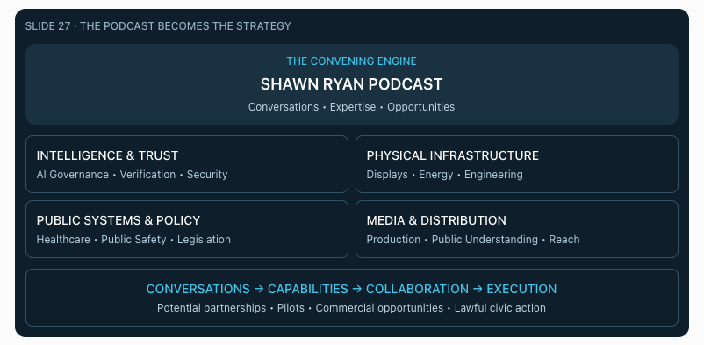

SLIDE 27 — THE PODCAST BECOMES THE STRATEGY
FROM CONVERSATIONS TO ACTION

[EDITOR CUE — JEETU: OPENING STRATEGY MAP]
Continue directly from Slide 26's final reveal:
THE PODCAST BECOMES THE STRATEGY.
Reveal the Shawn Ryan Podcast as the central convening engine.
Introduce the four capability groups progressively as the Narrator speaks.
Do not display the entire network at once.

[NARRATOR]
Measured, cinematic.
Every conversation introduces an opportunity.
Technology.
Infrastructure.
Expertise.
Capital.
And the people capable of bringing them together.
But the strategy isn't simply to have extraordinary conversations.
It's to discover what we can accomplish through them.

[EDITOR CUE — JEETU: FOUR CAPABILITY GROUPS]
Reveal the four groups in sequence.
ON-SCREEN TEXT ONLY — NO VOICEOVER
01 — INTELLIGENCE & TRUST
AI Governance • Verification • Security
02 — PHYSICAL INFRASTRUCTURE
Displays • Energy • Engineering
03 — PUBLIC SYSTEMS & POLICY
Healthcare • Public Safety • Legislation
04 — MEDIA & DISTRIBUTION
Production • Public Understanding • Reach
Use the existing dark navy and cyan design.
Keep the categories readable and the motion restrained.

[GEORGE]
Personal, deliberate. Building conviction.
Shawn, each guest brings something different.
A capability.
An experience.
A perspective.
And an opportunity to create value together.
For their businesses.
For the people involved.
And for a better future.
But here's what matters most.
We're not simply talking about what could be done.
We're showing the world that we're willing to try.
A discussion.
A shared vision.
A call to action.
And the determination to turn words into something real.

[EDITOR CUE — JEETU: CONNECTING THE CAPABILITIES]
As George describes the different opportunities, connect selected capability groups with subtle cyan lines.
Show how media, technology, industry, and public-policy expertise might support one another.
On:
“We're showing the world that we're willing to try.”
Begin illuminating the complete strategy map.
Do not imply that proposed guests or organizations have already committed to participating.

[NARRATOR]
Grounded, consequential.
Not every conversation will produce a partnership.
Not every idea will become a product.
Not every proposal will become law.
But every serious effort can teach us something.
What works.
What doesn't.
What needs to change.
And what might become possible when the right people work together.

[GEORGE]
Controlled, purposeful. Final declaration.
That's what makes this more than a conversation.
We're bringing people together.
Putting ideas to the test.
And doing everything within our capabilities to create meaningful value.
Not simply promising a better future.
Taking action to help build one.

[EDITOR CUE — JEETU: FINAL STRATEGY-MAP REVEAL]
Bring the network together.
Reveal the following progression:
ON-SCREEN TEXT ONLY — NO VOICEOVER
DISCUSSION → SHARED VISION → CALL TO ACTION → EXECUTION
Then display:
MORE THAN A CONVERSATION.
AN OPPORTUNITY TO CREATE VALUE THROUGH ACTION.
Hold briefly before introducing the first guest.

[GEORGE]
Deliberate. Introducing the first challenge.
Let's begin with a challenge that may shape every other technology we discuss.
Artificial intelligence.

[NARRATOR — TRANSITION TO SLIDE 28]
Serious, deliberate.
Before we ask what artificial intelligence can accomplish—
we must ask who it should serve.
And who establishes the boundaries it must never cross.
That brings us to Mo Gawdat.

[EDITOR CUE — JEETU: TRANSITION TO MO GAWDAT]
1. Highlight Intelligence & Trust
As George says “Artificial intelligence,” illuminate the Intelligence & Trust category.
Dim the other three groups.
2. Move into the first guest
As the Narrator asks who AI should serve, transition from the strategy map into a restrained AI-themed visual.
3. Introduce Mo Gawdat
Immediately after “That brings us to Mo Gawdat,” begin the existing Mo opening video.
SLIDE 28 — MO GAWDAT
Use his warning about artificial intelligence and institutions, followed by his more hopeful statement about humanity's future.
Do not insert another biography or opening montage before Mo's existing footage.

FINAL ON-SCREEN CONTENT — SLIDE 27
THE PODCAST BECOMES THE STRATEGY
From Conversations to Action
THE CONVENING ENGINE
SHAWN RYAN PODCAST
FOUR CAPABILITY GROUPS
- Intelligence & Trust
- Physical Infrastructure
- Public Systems & Policy
- Media & Distribution
FINAL REVEAL
DISCUSSION → SHARED VISION → CALL TO ACTION → EXECUTION
MORE THAN A CONVERSATION.
AN OPPORTUNITY TO CREATE VALUE THROUGH ACTION.

FINAL PRODUCTION NOTES — JEETU
Design: Retain the original four-category strategy-map layout, dark navy background, cyan accents, and clean typography.
Build: Reveal the podcast first, the four categories second, and the relationships third.
Visual emphasis: The story is about people and action, not simply connecting company logos. Use restrained motion and avoid overcrowding the screen.
Closing: Let George's final declaration carry the moment. Keep the completed network visible without adding another technical animation.
Transition: Highlight Intelligence & Trust as the gateway into Slide 28 — Mo Gawdat.
Accuracy: Guest relationships, collaborations, and commercial opportunities remain proposed rather than confirmed.

END OF SLIDE 27 — FINAL PRODUCTION SCRIPT

